Data Communication and Network
LAB

FAROOQ AHMAD Experiment # 7
17L4407 Lab Report # 6
BEE-5A

NETWORK ANALYSIS

INTRODUCTION
In this lab session, we were introduced to network analysis.
In network analysis, we were introduced to the various addresses of the computer devices and taught how we analyze various addresses and configurations of the devices.
IP address:
The IP address is a unique 32-bit address used to identify each machine on the network. Every device connected to the internet has its own unique identifying number, which is called its IP address or Internet Protocol address. An example of a computer IP address would be 192.168.1.10, where the number 10 in this case corresponds to the computer’s address on the local network.
MAC address:
A MAC address is essentially a unique, fixed serial number of your computer’s network card in a globally agreed format. This network card can also be referred to as a Network adapter or Network Interface Card (NIC).
ARP:
Address resolution Protocol (ARP) is a network layer protocol used to convert an IP address into a physical address. A host wishing to obtain a physical address broadcasts an ARP request onto the TCP/IP network. The host on the network that has the IP address in the request then replies with its physical hardware address.
RARP:
Reverse Address Resolution Protocol (RARP) is a network layer protocol used to obtain an IP address for a given hardware address.

OBJECTIVE

The course learning objective of this lab session was to introduce us to the network analysis of a computer network device and to understand different computer network tools like ping, tracert and their usage.

DESIGN PROCEDURE
The procedure of this lab experiment was to run and analyze network analysis commands.

IP Config Command
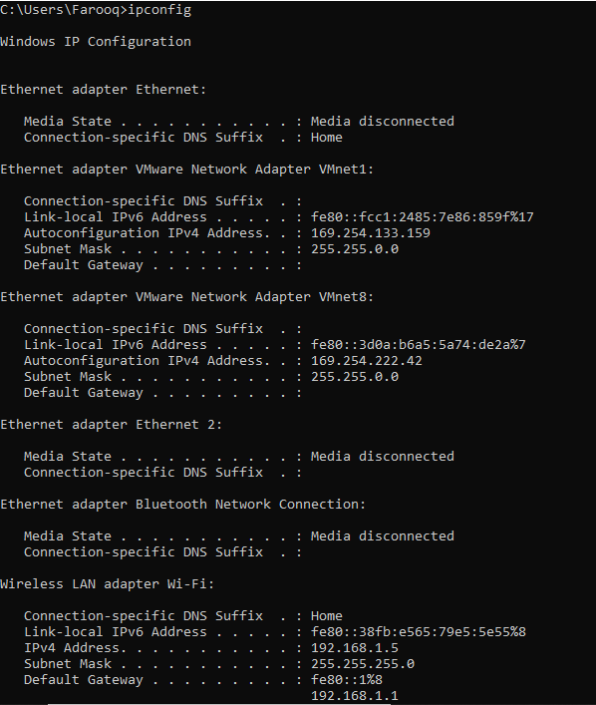
Ping
>ping ipaddress
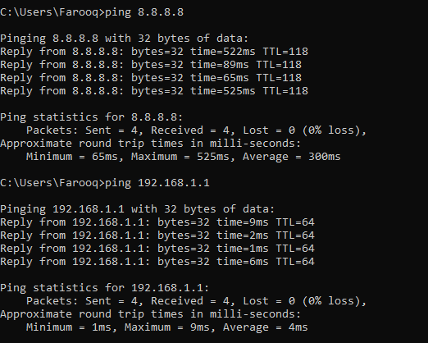
>ping -t ipaddress (keep pinging until manually stopped)
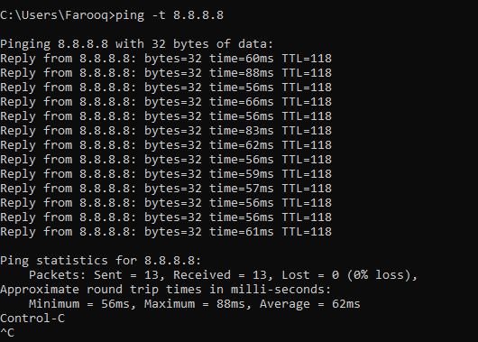
>ping -n count ipaddress (ping with n packets)
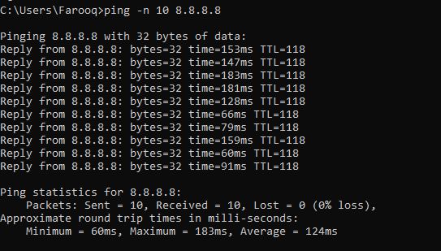
Tracert
>tracert hostname [use any website e.g., www.google.com]
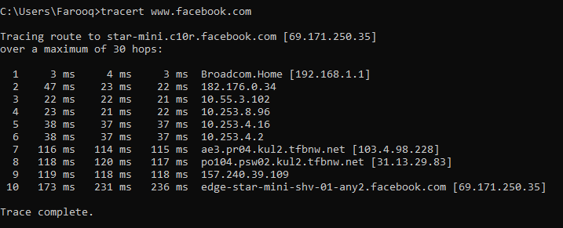
Produce route trace using the site http://www.net.princeton.edu/traceroute.html for the following URLs:
- www.nu.edu.pk
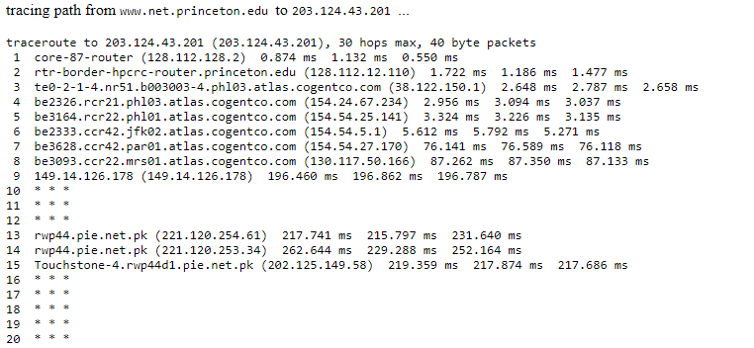
Done.
- www.mit.edu
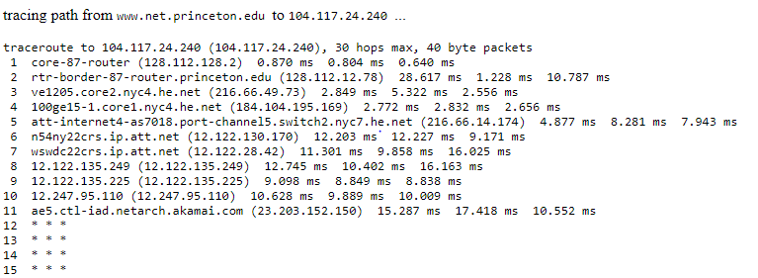
Done.
MAC address
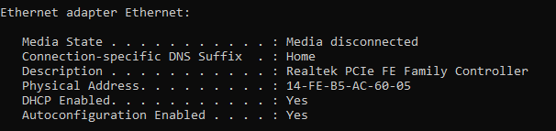
Physical address is the mac address of my machine
14-FE-B5-AC-60-05
Address resolution Protocol (ARP)
> arp –a (Display the ARP cache tables for all interfaces)
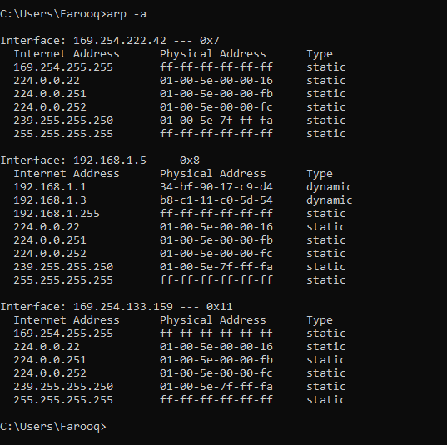

ISSUES
There were as such none issues.

CONCLUSION
This lab session was conducted successfully. The network analysis terms and techniques were learnt and a network analysis procedure was performed. Network analysis is the process of capturing network traffic and inspecting it closely to determine or analyze what happened on the network. A network analyzer decodes, or dissects the data packets of common protocols and displays the network traffic in human-readable format

APPLICATIONS
Network analysis (also known as traffic analysis, protocol analysis, sniffing, packet analysis, eavesdropping, and so on) is the process of capturing network traffic and inspecting it closely to determine what is happening on the network. A network analyzer decodes the data packets of common protocols and displays the network traffic in readable format. A network analyzer can be a standalone hardware device with specialized software, or software that is installed on a desktop or laptop computer.

POST LAB
Question 1.
Why we need both IP and MAC addresses?
MAC Addresses handle the physical connection from computer to computer while IP Addresses handle the logical routeable connection from both computer to computer AND network to network.
Question 2.
What is the purpose of “Maximum hop limit” in tracert command?
This command determines the path by sending the first echo Request message with a TTL of 1 and incrementing the TTL by 1 on each subsequent transmission until the target responds or the maximum number of hops is reached. The maximum number of hops is 30 by default and can be specified using the /h parameter.
Question 3.
Why is a “rarp” command not needed?
RARP command is used to convert ip address to mac address. But a device has both its ip address and its physical address. That’s why we don’t the command rarp to convert ip address to mac address.

